Polynomial Fit

Just as a mean curve can be thought of as a model of a dataset that has a smoothing effect, a polynomial model can also be used as a smoothing mechanism to capture key aspects of a dataset without all the “rough edges.”

Suppose you want to determine the time of maximum for the following Mira maximum light curve segment.

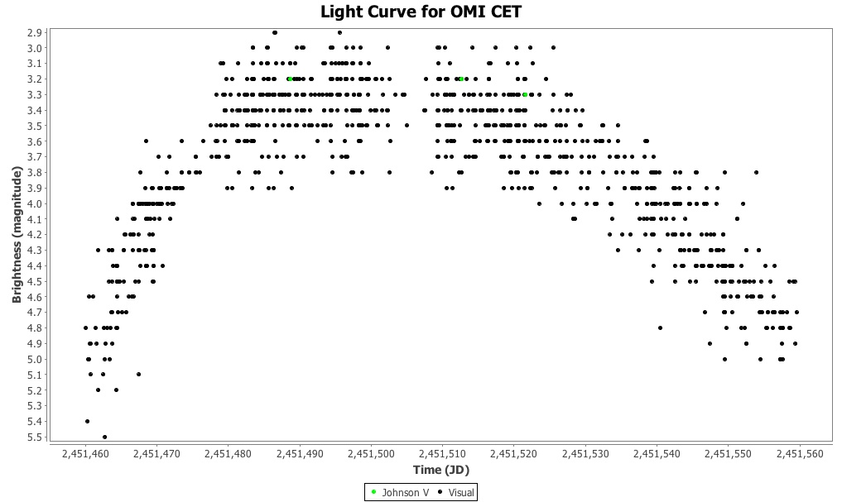

One way to do this is by fitting a polynomial to the data and using that to determine what the time of maximum is. The relationship between a sequence of x (time) values and corresponding dependent y (magnitude) values can be modeled as an nth order polynomial.
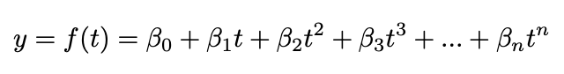
A polynomial model of degree n is defined as a function of time with the following form:

where t is time (e.g. Julian Date) and β_{n} is a coefficient. The sum of these coefficients multiplied by corresponding time values, each raised to a power (the number or index of the coefficient: 0...n), creates a curve that approximates the data. Notice that β₀ is just β₀ t⁰. The process through which the coefficients are determined is beyond the scope of this document. See References and Further Reading for more background information about polynomial models and data fitting.

The degree of the polynomial will have a bearing on the values of the minima or maxima (critical points or extrema) found since (roughly speaking) the higher the degree, the better the polynomial approximates the features of the data.

In VStar, a polynomial fit can be created via the Analysis → Polynomial Fit... menu item or the corresponding toolbar button.

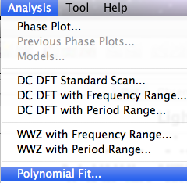
Selecting one of these will result in a Series Selection Dialog being invoked
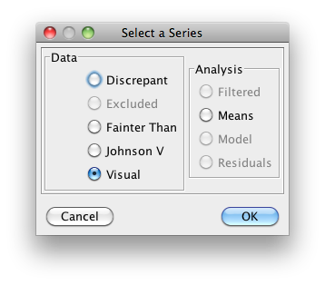
In this case, the Visual series is selected and clicking the OK button yields the polynomial degree dialog.
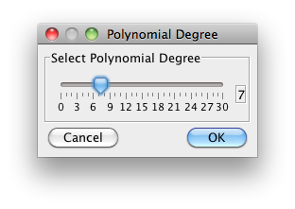
This is used to specify the number of degrees for the polynomial to be created, 7 in this case. Clicking the OK button creates the polynomial fit of the Visual series and adds a Model series as follows:

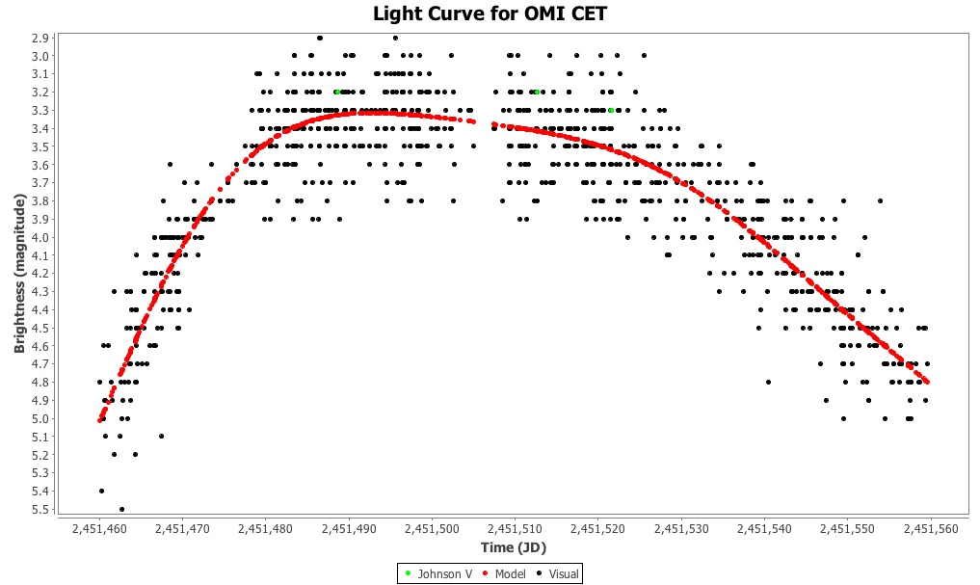

Foster (2010) discusses essentially the same example except that R (a statistical programming language) is used rather than VStar. The Model tab contains a list of the polynomial fit data points visible on the plot.

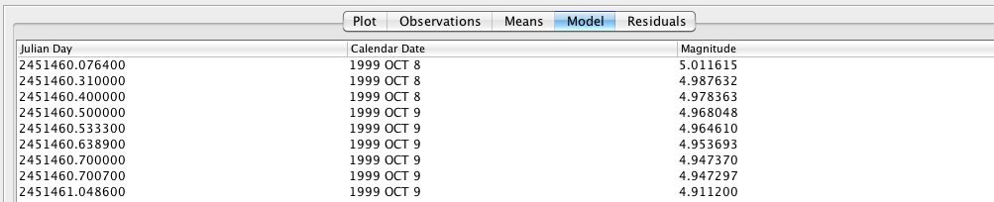

The Residuals tab contains a list of the residuals (observation minus model for each such pair of values) from the polynomial fit.

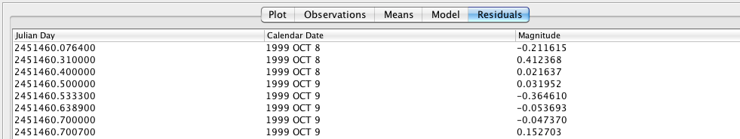

This series can also be viewed on the Plot pane by selecting the Residuals series in the Plot Control Dialog series visibility checkboxes.
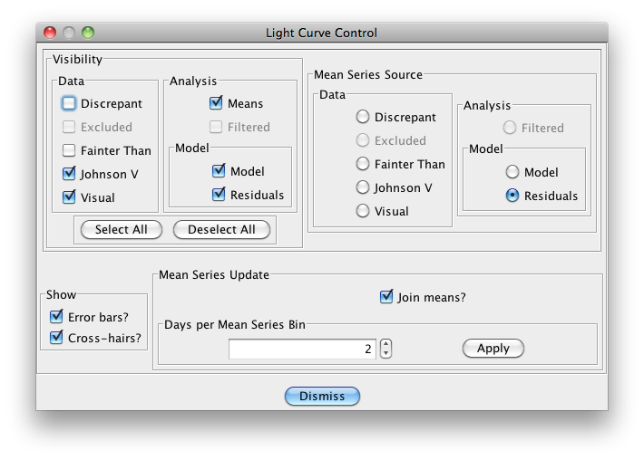
In addition, as shown above, if the Residuals mean series source radio button is selected and Days per Mean Series bin set to 2, as shown, the Plot Pane will look like this:

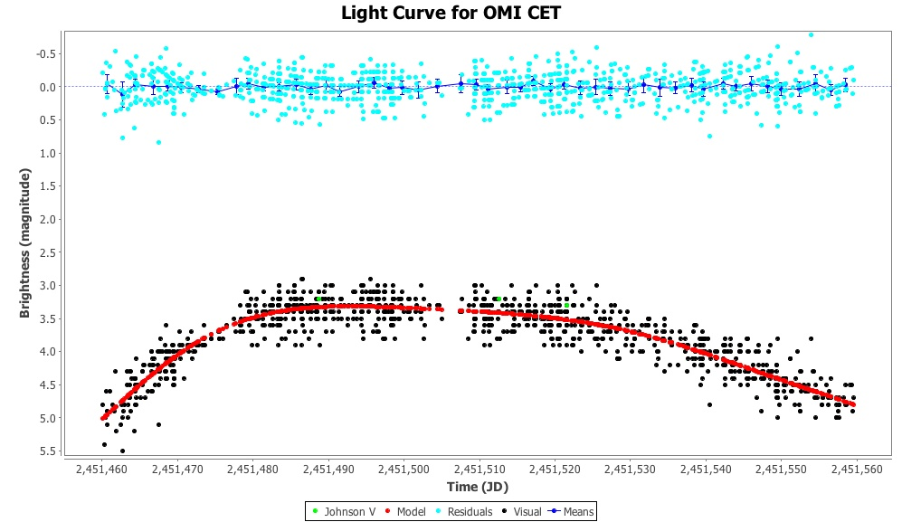

As for a model or residuals plot, mean plot data points can be viewed in tabular format in the Means list by selecting the corresponding tab, for example:

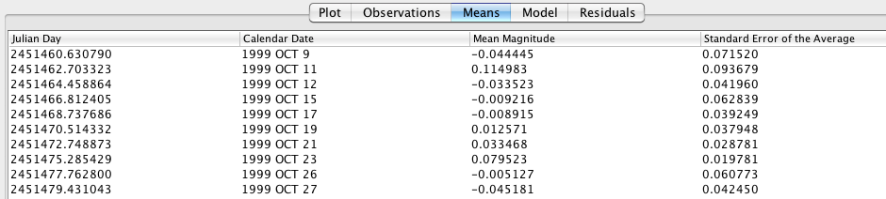

The Current Mode ANOVA plug-in could be used to show that there is no significant signal remaining, and that the fit is apparently a good one, since what is observed in the residuals is likely to be due to noise rather than the presence of a non-trivial signal.

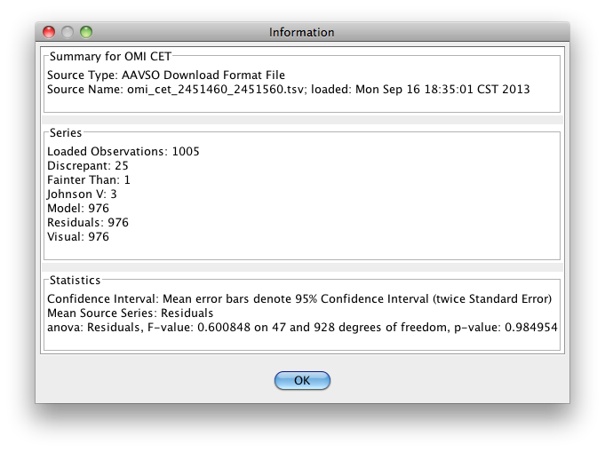
Additional information about created models can be obtained via the Model Information dialog. This can be invoked from the Analysis menu’s Models… item:

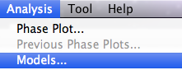

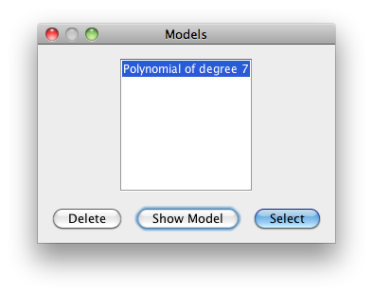
A model can be deleted via the Delete button. The Select button is used to select the highlighted model in the list for viewing on the Plot Pane and the Model and Residuals lists.

Selecting the Show Model button invokes the following dialog:
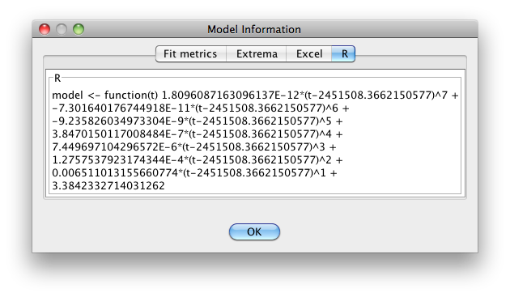
The Model Information dialog gives:

- Excel and R functions for the polynomial.
- The Root Mean Square (RMS) value for the fit.
- Akaike and Bayesian Information Criteria, goodness of fit measures (AIC, BIC).
- Where they can be determined, extrema (minimum and maximum magnitude and JD).

Note that some details of this list may change in future VStar versions, e.g. additional function representations, information criteria, extrema determination methods.

Notice that the Excel and R functions reveal the polynomial degree in the number of coefficients as explained earlier in this section. Notice also that each time term has a Julian Date zero-point subtracted from it, reflecting the way in which the polynomial fit was created, in order to reduce the magnitude of values (and possible loss of precision) when higher powers are involved.

The R function can be used in conjunction with observations, model data and the script available at the following location to plot the model equation:

https://sourceforge.net/p/vstar/code/HEAD/tree/trunk/script/plot_model.R

The Excel formula should be copied and pasted into a text editor and newlines removed before pasting it into Excel.

A treatment of RMS and Information Criteria is beyond the scope of this document. See Foster (2010) and the relevant “Polynomial Fit” sub-section of References and Further Reading.

A polynomial fit can also be useful to characterize the overall shape of some light curves. Take for example the following light curve for Nova Delphini 2013:

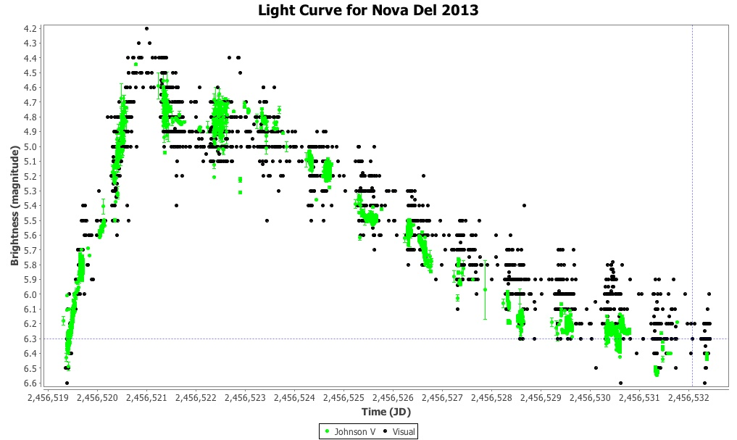

A polynomial of degree 8 gives this:

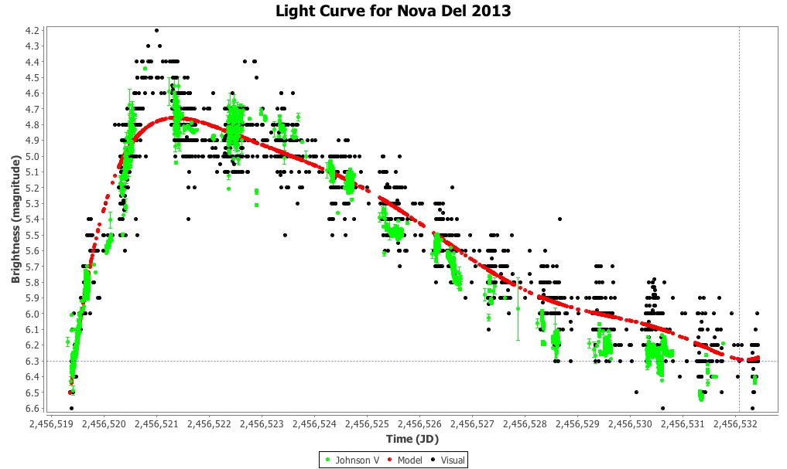

Note that this could also be useful in determining the rate of decline after maximum magnitude is reached.

